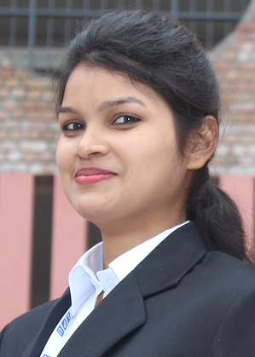

Neha
Female
Email: Nehagnkcw@gmail.com
M: 7508250184

RESUME
CAREER OBJECTIVE
To Work for an Organization which provides me the opportunity to improve my skills and knowledge to growth along with the organization Objective.
ACADEMIC QUALIFICATIONS

Year | Degree | Institute | CGPA / Percentage
2014 | Diploma | V-Tech | 80%
2013 | XII | P.S.E.B | 79.1%
2011 | X | P.S.E.B | 73.5%
Project Name : TOUR and TRAVEL
PROJECT DETAIL
Team Size : 2
Build In : HTML and CSS
Responsibility : Designer and Coder

ACHIEVEMENTS
- Got First position in TAEKWONDO Haryana State Level.

STRENGTH
- Good Skills in Web Development languages.
- To do my Work With Honesty and Hard Work.
- Dedication and Confidence to my work is my Strength

LANGUAGE PROFICIENCY
- English
- Hindi
- Punjabi

PERSONAL DETAILS
- Date of Birth : 17th March 1996
- Nationality : India
- Address : H. No 655/2A Punjab Mata Nagar near Govt school Ludhiana.

Declaration: I hereby declare that the details furnished above are true and correct to the best of my knowledge and belief and I undertake to inform you of any changes therein, immediately.

Date:- Signature:-

